**Lab 17 : Skills Integration Challenge-Network Planning and  Interface Configuration**

**Topology Diagram**

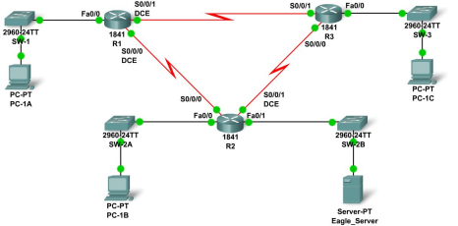

|  |  |  |  |  |
| --- | --- | --- | --- | --- |
| **Device** | **Interface** | **IP Address** | **Subnet Mask** | **Default Gateway** |
| **R1** | **Fa0/0** | **192.168.1.62** | 255.255.255.192 | **N/A** |
| **S0/0/0** | **192.168.1.129** | 255.255.255.252 | **N/A** |
| **S0/0/1** | **192.168.1.133** | 255.255.255.252 | **N/A** |
| **R2** | **Fa0/0** | **192.168.1.110** | 255.255.255.240 | **N/A** |
| **Fa0/1** | **192.168.1.94** | 255.255.255.224 | **N/A** |
| **S0/0/0** | **192.168.1.130** | 255.255.255.252 | **N/A** |
| **S0/0/1** | **192.168.1.137** | 255.255.255.252 | **N/A** |
| **R3** | **Fa0/0** | **192.168.1.126** | 255.255.255.240 | **N/A** |
| **S0/0/0** | **192.168.1.138** | 255.255.255.252 | **N/A** |
| **S0/0/1** | **192.168.1.134** | 255.255.255.252 | **N/A** |
| **PC-1A** | **NIC** | **192.168.1.1** | 255.255.255.192 | **192.168.1.62** |
| **PC-1B** | **NIC** | **192.168.1.97** | 255.255.255.240 | **192.168.1.110** |
| **PC-1C** | **NIC** | **192.168.1.113** | 255.255.255.240 | **192.168.1.126** |
| **Eagle_Server** | **NIC** | **192.168.1.93** | 255.255.255.224 | **192.168.1.94** |